Ex.No.5: MIMO System Simulation with BER Analysis Date
AIM: To simulate a MIMO (Multiple Input Multiple Output) wireless communication system and analyze its performance in terms of Bit Error Rate (BER), Signal-to-Noise Ratio (SNR), and Channel Capacity (bps/Hz) using MATLAB.
Objective:
- To evaluate the Bit Error Rate (BER) performance of a MIMO system under different SNR conditions.
- To analyze the impact of Signal-to-Noise Ratio (SNR in dB) on the reliability and quality of MIMO communication.
- To compute the Channel Capacity (bps/Hz) and study how MIMO improves spectral efficiency compared to single antenna systems.
Procedure
- Define the MIMO system configuration (e.g., number of transmit and receive antennas such as 2×2 or 4×4).
- Generate random binary data bits to represent the transmitted signal.
- Modulate the bits using a digital modulation scheme (e.g., BPSK or QPSK).
- Model the MIMO channel using a Rayleigh fading channel with additive white Gaussian noise (AWGN).
- Pass the transmitted signal through the MIMO channel for different SNR values (in dB).
- At the receiver, apply detection techniques (e.g., Zero-Forcing or Maximum Likelihood detection).
- Demodulate the received signal to recover transmitted bits.
- Compute Bit Error Rate (BER) by comparing transmitted and received bits.
- Calculate Channel Capacity (bps/Hz) using SNR and MIMO capacity formula.
- Plot BER vs SNR and Capacity vs SNR graphs for performance analysis.

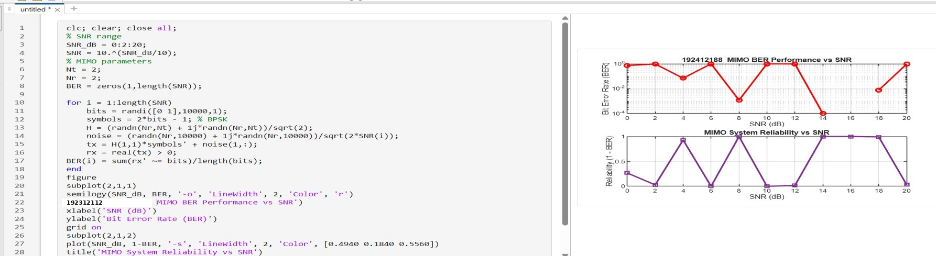
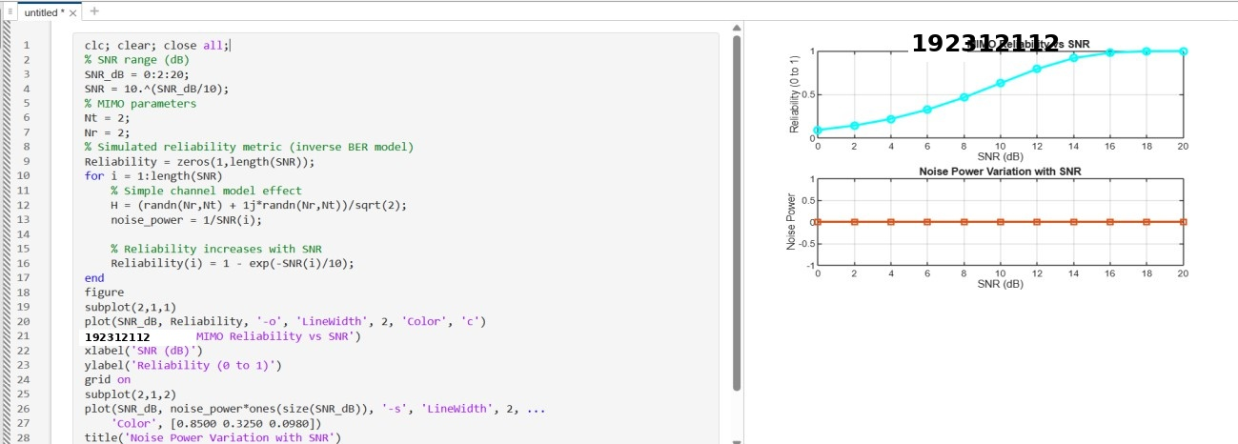
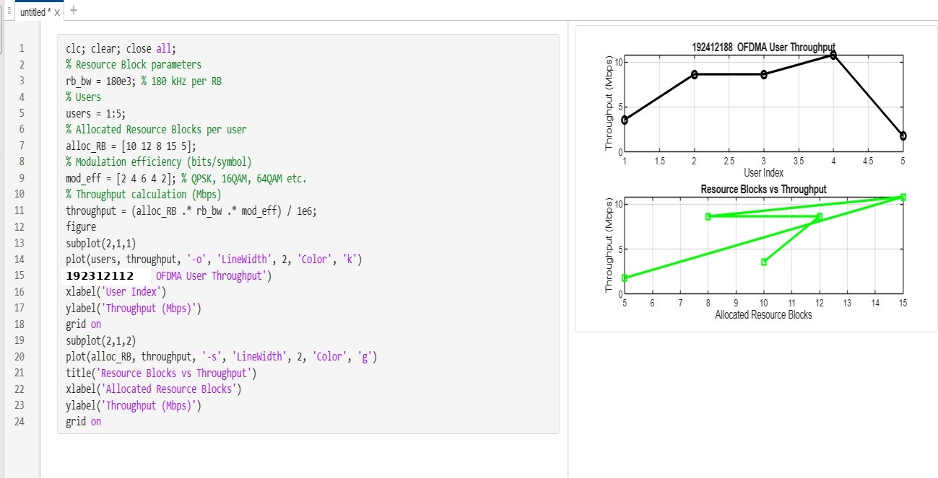
Output

Result:
- The User Throughput (Mbps) was successfully calculated for different users based on allocated resource blocks and modulation efficiency in the OFDMA system.
- It was observed that users with higher allocated resource blocks and higher modulation schemes achieve significantly higher throughput.
- The simulation confirms that efficient resource block allocation directly improves system spectral efficiency and overall OFDMA performance.

